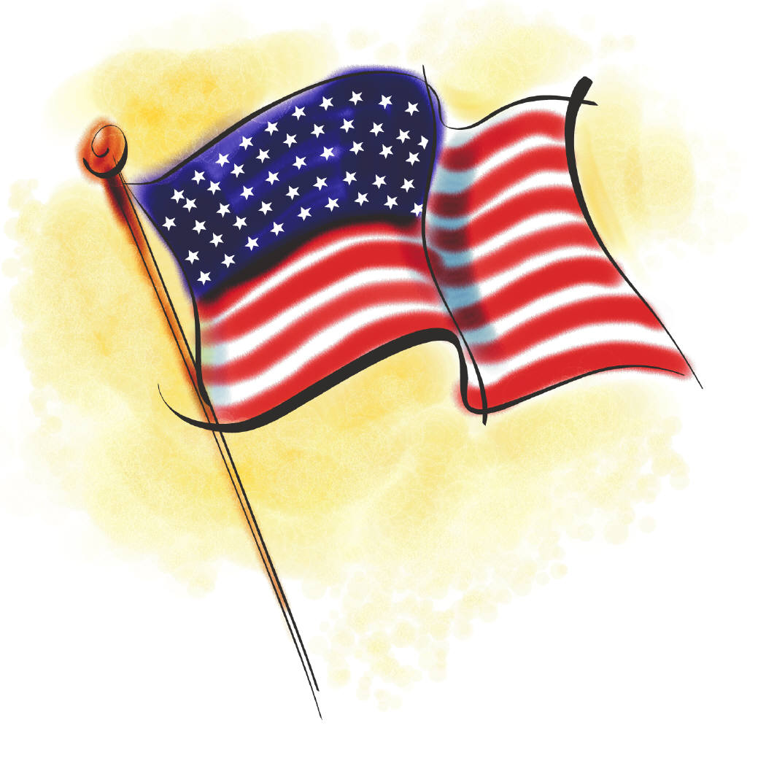
Veterans Day

October 1, 2024

Dear Yarbrough Family,

Every year, Americans set aside November 11, Veterans Day, to honor those in our Armed Forces who have served our country in times of war and peace. The faculty, staff, and students at Yarbrough Elementary School will honor those who have served in the United States Armed Forces on Friday, November 8, 2024, at 8:00 a.m. Students who would like to recognize a veteran may invite him/her to our Veterans Day program that will be held on this date.

Veterans should arrive at Yarbrough Elementary School between 7:35 a.m. and 7:50 a.m. on Friday, November 8, 2024 to participate in our program. Following our program, veterans and their Y.E.S. host-student(s) are invited to a reception in the school library.

Thank you for assisting us in showing appreciation to those who have demonstrated bravery and courage for our freedom.

Sincerely,
Lisa Wheatley
Principal, Yarbrough Elementary School

Once your veteran has confirmed that she/he will be able to attend the Veterans Day program, please complete the Veterans Day Information Form no later than October 17, 2024.
